**Question1:**

We use the following formulas for the Interarrival time and Service duration time.

Intra Arrival Time = $-\ln\left(1-rand( )\right)*(\frac{1}{0.3})$

Service Duration Time = $2*rand\left(∙\right)+2.5$

The Simulation is shown in the excel file.

1. # of Customers served = **46**
2. Total Waiting time/ delay (mins) = **1160.19**
3. Avg waiting time per customers (mins) = **25.22**

**Question 2:**

Cumulative Arrival $=\left\{\begin{matrix}8t & 0≤t≤30 \\ 2t+180 & t>30\end{matrix}\right.$

Cumulative Departure $=\begin{matrix}5t & t≥0\end{matrix}$

**Equating,**

We get,

2t + 180 = 5t

Therefore, t = 60

That is, the queue will disappear at 60 minutes.

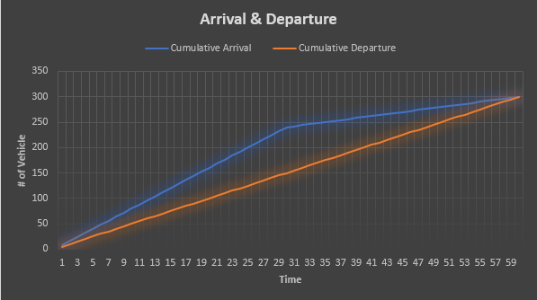

Total Waiting Time = Ttotal = area between two curves

= (30*240) + (½ *30*240) + (½ * 30*60) – ½ *60*300

= **2700 mins**

Average Queue Length, Lavg = 2700/60 = **45 cars**

Average Waiting Time, Tavg = 2700/300 = **9 mins**

Refer to excel sheet for further calculations.

**Question 3:**

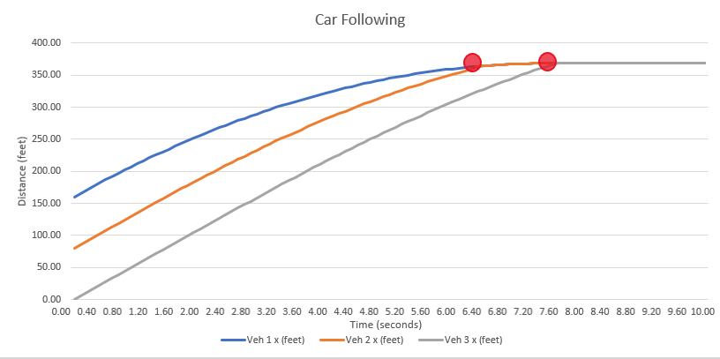

The vehicle Trajectories have been plotted against time.

The two red dots indicate collision points.

The collisions occur at **6.4 seconds** at **363.89 feet** i.e, 96.11 feet away from the signal.

And **7.7 seconds** at **368.69 feet** i.e, 91.11 feet away from the signal.

Please refer to the excel file for detailed calculations.